PROJECT REPORT
Secure Orphanage Resource Management System

Database And Management System (UCS310)
Submitted by:
Icy Agarwal 1024030823
Harshit Taneja 1024030826
Riddhi Dhawan 1024030943

BE Second Year Batch: 2C61
Submitted to:
Ms. Banisha



DEPARTMENT OF COMPUTER SCIENCE AND ENGINEERING THAPAR INSTITUTE OF ENGINEERING AND TECHNOLOGY,
PATIALA, PUNJAB
JAN-JUNE 2026

Submission Date: 1 May 2026

Contents
1. INTRODUCTION 3
2. PROBLEM STATEMENT 3
3. OBJECTIVES OF THE PROJECT 3
4. SCOPE OF THE PROJECT 4
5. LIMITATIONS 4
6. LITERATURE REVIEW 5
6.1 EXISTING SYSTEMS AND RELATED WORK 5
6.2 COMPARISON TABLE 5
6.3 RESEARCH GAP ADDRESSED 5
7. PROPOSED SYSTEM DESCRIPTION 6
8. DATABASE DESIGN 6
8.1 Relational Schema 7
9. NORMALIZATION 7
10. DATABASE IMPLEMENTATION 8
11. TOOLS & TECHNOLOGIES USED 10
12. RESULTS 10
13. CONCLUSION 13
14. REFERENCES 13

INTRODUCTION

The Secure Orphanage Resource Management System is a database-driven platform designed to manage child welfare records and resource distribution in orphanages. Orphanages handle highly sensitive and critical information, including personal details of children, medical history, educational progress, donations received, and allocation of essential resources such as food, clothing, and financial aid.
In many institutions, such information is still maintained through manual registers or loosely structured digital files. These approaches lead to redundancy, inconsistency, limited security, and difficulty in tracking resource utilization. A Database Management System (DBMS) provides a structured, centralized, and secure mechanism for handling such data efficiently.
This project emphasizes backend implementation using SQL and MySQL Stored Procedures, Functions, and Triggers. It incorporates normalization techniques to reduce redundancy, role-based access control to restrict unauthorized access, and audit logging with controlled database access to ensure confidentiality of sensitive child information.The system aims to ensure data integrity, transparency, and ethical management of orphanage operations

PROBLEM STATEMENT

Orphanages require a structured system to manage welfare records and resources effectively.
However, existing manual or file-based systems suffer from the following limitations:
- Data redundancy and inconsistency
- Lack of proper security for confidential child data
- Inefficient tracking of donations and resource allocation
- Absence of structured relationships between entities
- Limited accountability and transparency
There is a need for a secure, well-structured relational database system that ensures confidentiality, maintains referential integrity, and optimizes the allocation of available resources.
The project addresses this gap by developing a normalized database system that securely manages child records, donation tracking, and resource distribution using SQL and MySQL procedural automation.

OBJECTIVES OF THE PROJECT

The major objectives of the project are:
- To design an Entity–Relationship (ER) model representing orphanage operations.
- To convert the ER model into a relational schema with appropriate primary and foreign keys.
- To apply normalization up to 3NF/BCNF to eliminate redundancy.
- To implement the database using SQL (DDL and DML commands).
- To develop advanced SQL queries including joins, subqueries, aggregate functions, and views.
- To implement MySQL procedural components such as stored procedures, functions, and triggers.
- To ensure data security using role-based access control, audit logging, and controlled database access.
- To implement role-based access control for Admin, Staff, and Auditor roles.
- To ensure transaction consistency using COMMIT, ROLLBACK, and SAVEPOINT commands.

SCOPE OF THE PROJECT

The scope of this project is limited to backend database implementation.

Functional Modules:
- Child Welfare Record Management
- Donation Management
- Resource Inventory Management
- Resource Allocation Tracking
- User Role & Access Control

Types of Users:
- Admin: Full database privileges
- Staff: Data entry and management access
- Auditor: Read-only access for transparency

The system focuses strictly on database – level implementation rather than front-end development.

LIMITATIONS

- The system is limited to backend database implementation and a basic web interface; no mobile application has been developed.
- Encryption of sensitive data is handled at the access control level and not at the column level (column-level encryption requires Oracle or enterprise-grade DBMS features).
- The system does not include biometric authentication or real-time notifications.
The frontend is a prototype demonstrating live database connectivity; it is not a production-grade application.

LITERATURE REVIEW

EXISTING SYSTEMS AND RELATED WORK
Child Welfare Information Gateway (USA) A federal system maintained by the U.S. Department of Health and Human Services for managing foster care and adoption records. It provides structured data management for child welfare but is limited to US jurisdiction and does not address resource allocation or donation tracking workflows relevant to orphanage management.
Hospital Management Systems (HMS) Systems such as OpenMRS and Bahmni address medical record management with normalization and role-based access control. Their data models inspired the design of our Children table with Medical Record attributes. However, these systems lack donation management and per-child resource allocation modules entirely.
NGO Resource Management Tools (Salesforce Nonprofit) Offers donor CRM features and donation tracking but is not tailored for orphanage-specific workflows. It does not support per-child resource allocation, audit logging through database triggers, or database-level procedural implementation using MySQL stored routines and triggers.
Academic Work — Database Design for Social Welfare Organizations Proposes ER models for NGOs covering donor-beneficiary relationships and basic normalization. However, it does not address MySQL procedural automation, triggers, role-based access control at the database level, or transaction management — all of which are core to our system.

COMPARISON TABLE
SYSTEM | CHILD RECORDS | DONATION TRACKING | RESOURCE ALLOCATION | RBAC | SQL/PL/SQL
Child welfare gateway | ✓ | ✗ | ✗ | ✓ | ✗
Salesforce Nonprofit | Partial | ✓ | ✗ | ✓ | ✗
OpenMRS | ✓ | ✗ | ✗ | ✓ | ✗
Academic NGO model | ✓ | ✓ | ✗ | Partial | ✗
Our system | ✓ | ✓ | ✓ | ✓ | ✓

RESEARCH GAP ADDRESSED
• No existing system combines child welfare records, donation management, resource allocation, and MySQL procedural automation in a single backend database.
• Audit logging through database triggers is absent in all reviewed systems.
• Role-based access control enforced at the database level using GRANT statements is rarely implemented in academic NGO database models.
• Our system addresses all these gaps through an integrated, normalized MySQL implementation with automated triggers and transaction management.

PROPOSED SYSTEM DESCRIPTION

The proposed system is a secure relational database implemented using MySQL, Stored Procedures, Functions, and Triggers. It maintains structured records of children, staff, donations, resources, and allocations.
Key system features include:
- Secure storage of sensitive data using role-based access control and controlled database access.
- Role-based access restrictions
- Automated triggers for audit logging
- Efficient data retrieval using optimized SQL queries
- Transaction management to maintain consistency

The system improves operational efficiency by reducing redundancy and ensuring referential integrity through foreign key constraints. Automated stored procedures help manage repetitive operations such as allocation processing and reporting.

DATABASE DESIGN

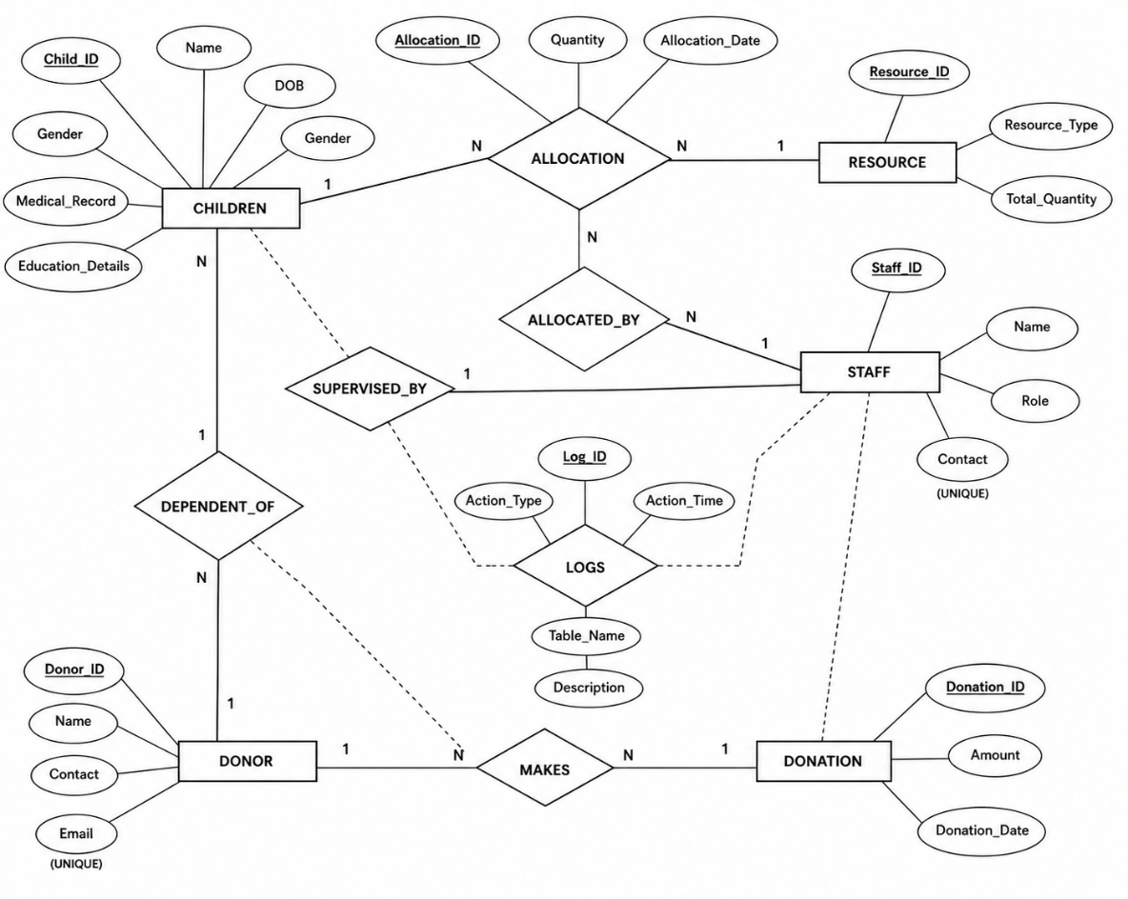

Relational Schema
Children (Child_ID, Name, DOB, Gender, Medical_Record, education_Details)
Staff (Staff_ID, Name, Role, Contact)
Donor (Donor_ID, Name, Contact, Email)
Donation (Donation_ID, Donor_ID, Amount, Donation_Date)
Resource (Resource_ID, Resource_Type, Total_Quantity)
Allocation (Allocation_ID, Child_ID, Resource_ID, Staff_ID, Quantity, Allocation_Date)
Audit_Log (Log_ID, Action_Type, Table_Name, Action_Time, Description)

*Underline = Primary Key, Italics = Foreign Key

NORMALIZATION

First Normal Form (1NF)
All attributes in every table contain atomic, single-valued data. For example, Medical_Record stores one string per child, Gender uses an ENUM constraint ensuring a single controlled value, and no repeating groups exist anywhere in the schema.

Second Normal Form (2NF)
All non-key attributes are fully functionally dependent on the entire primary key. Since every table uses a single-column surrogate primary key (AUTO_INCREMENT), partial dependency is structurally impossible. For example, in the Allocation table, Quantity and Allocation_Date depend entirely on Allocation_ID, not on any subset of it.

Third Normal Form (3NF)
No transitive dependencies exist. Donor information (Name, Contact, Email) is stored in the Donor table and referenced in Donation via Donor_ID as a foreign key — donor details are never repeated inside Donation. Similarly, Staff details are not duplicated inside Allocation; only Staff_ID is stored as a reference.

Boyce-Codd Normal Form (BCNF)
Every determinant in every table is a candidate key. The UNIQUE constraints on Staff.Contact and Donor.Email make them candidate keys, and they determine only attributes directly belonging to their own entity. All tables satisfy BCNF conditions.

DATABASE IMPLEMENTATION

10.1 SQL Implementation

- DDL commands
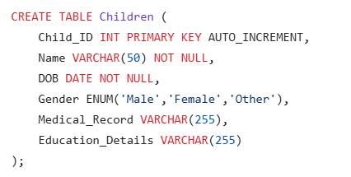

- DML commands (INSERT, UPDATE, DELETE)
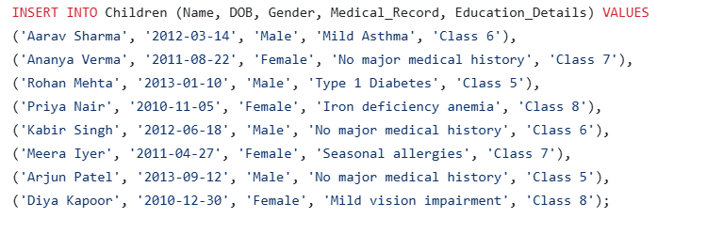
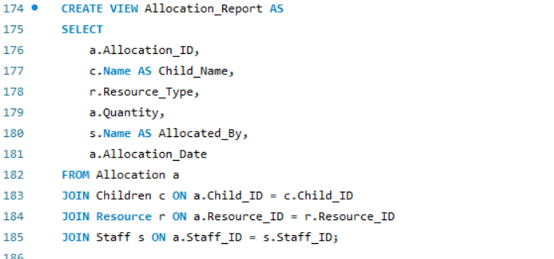
- SELECT queries using joins

- Subqueries
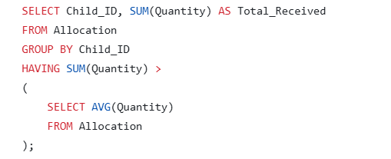

- Aggregate functions
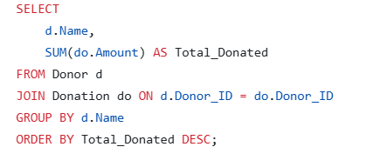

- GROUP BY and HAVING clauses
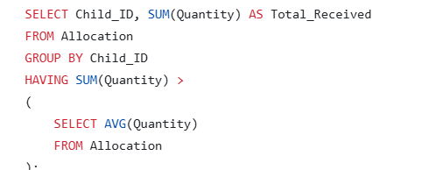

10.2 MySQL Procedural Components

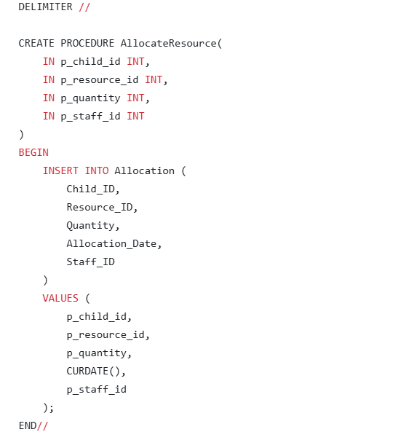
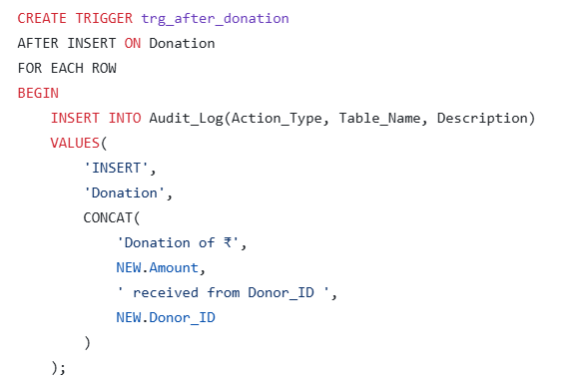

TOOLS & TECHNOLOGIES USED

- MySQL
- SQL
- MySQL Workbench
- MySQL Stored Procedures, Functions & Triggers

RESULTS

- SHOW TABLES

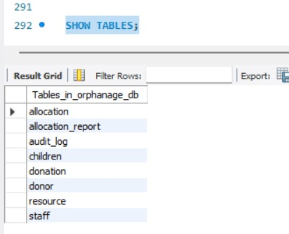
- DESC CHILDREN

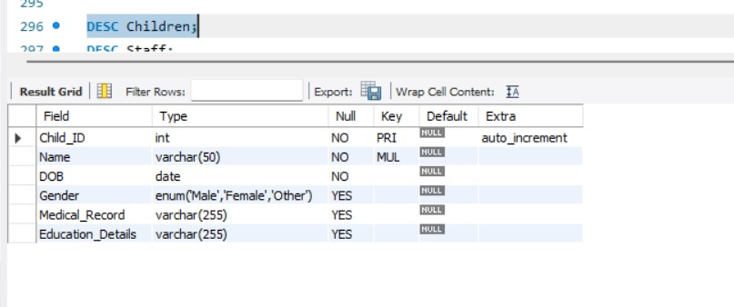

- CHILDREN TABLE

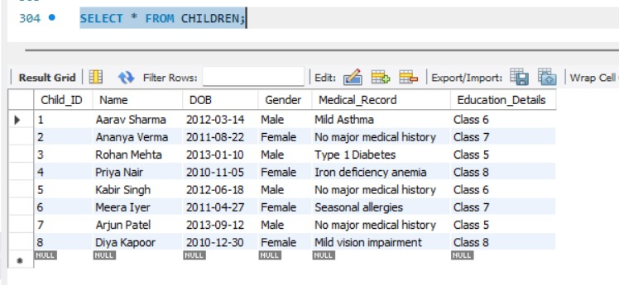

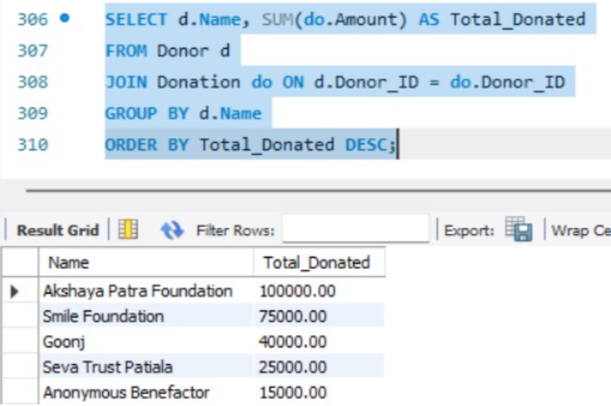

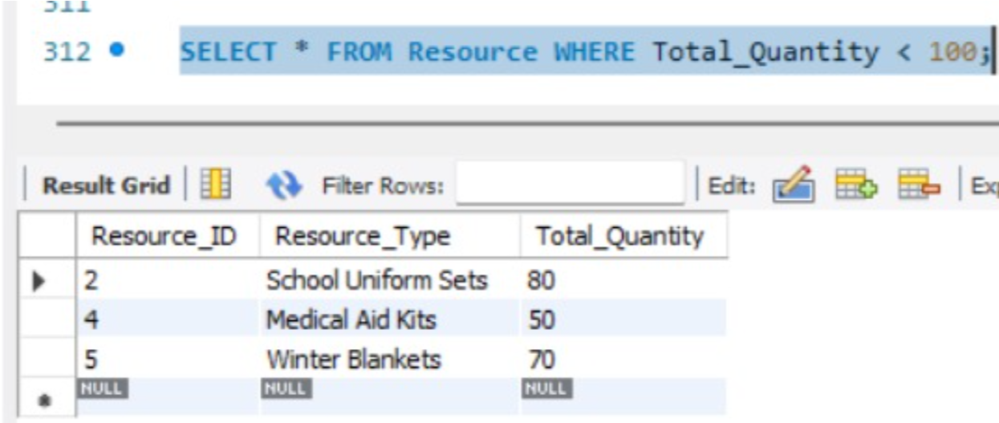

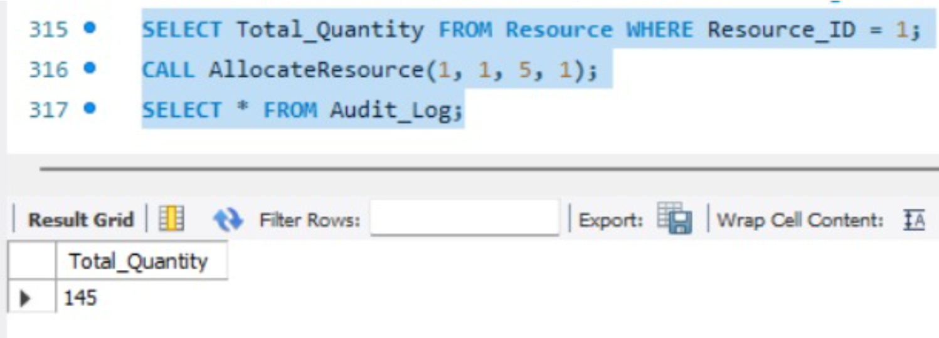

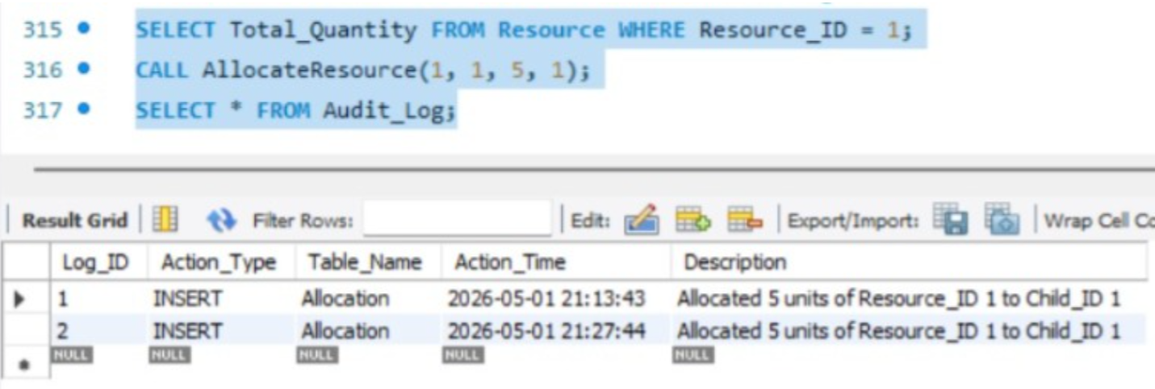

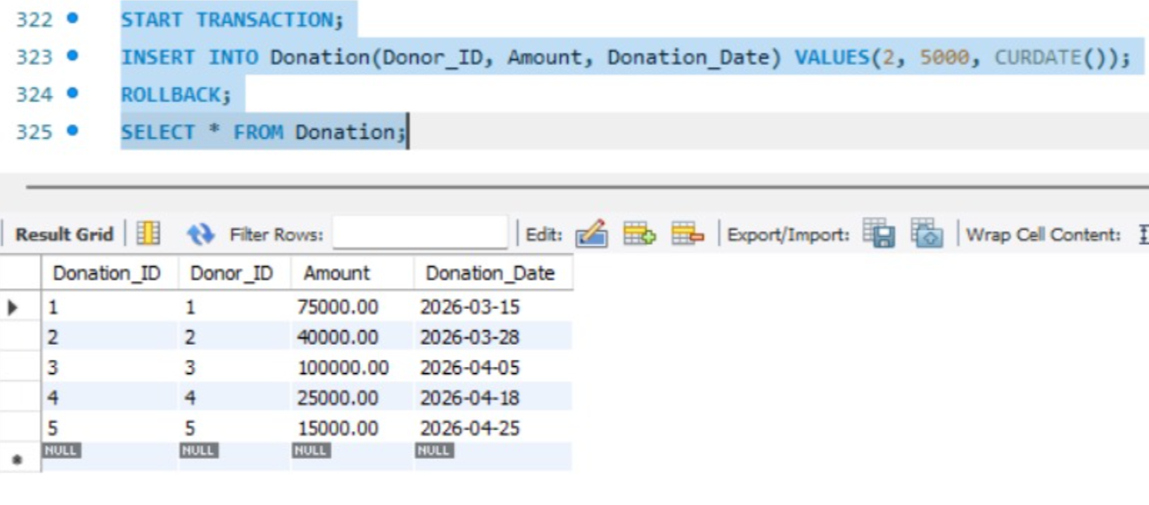

CONCLUSION

The Secure Orphanage Resource Management System (SORMS) successfully demonstrates the practical application of core Database Management System concepts in a socially meaningful domain. By integrating SQL and MySQL procedural backend development with normalization up to BCNF, automated triggers, transaction management, and role-based access control, the project establishes a secure and efficient system for managing sensitive orphanage data.

The system achieves all stated objectives — a fully normalized 7-table relational schema, comprehensive DDL and DML implementation, advanced SQL queries using joins, subqueries, aggregate functions and views, three automated audit triggers, a stored procedure and function for procedural automation, four performance indexes, and a three-tier RBAC security model.

A key highlight of this project is the trigger-based audit logging system, which automatically records every allocation and donation event in real time without any manual intervention — ensuring complete transparency and accountability in orphanage operations.

Future extensions could include a web-based front-end interface, column-level encryption for Medical Record fields, multi-branch orphanage support, and integration with online payment gateways for donation collection.

REFERENCES

[1] Ramakrishnan, R., & Gehrke, J. (2002). Database Management Systems (3rd ed.). McGraw-Hill.
[2] Silberschatz, A., Korth, H. F., & Sudarshan, S. (2019). Database System Concepts (7th ed.). McGraw-Hill.
[3] Codd, E. F. (1970). A Relational Model of Data for Large Shared Data Banks. Communications of the ACM, 13(6), 377–387.
[4] Date, C. J. (2003). An Introduction to Database Systems (8th ed.). Addison-Wesley.
[5] MySQL 8.0 Reference Manual. Oracle Corporation. https://dev.mysql.com/doc/refman/8.0/en/
[6] MySQL Stored Procedures and Functions. Oracle Corporation. https://dev.mysql.com/doc/refman/8.0/en/stored-routines.html
[7] MySQL Triggers Documentation. Oracle Corporation. https://dev.mysql.com/doc/refman/8.0/en/triggers.html
[8] MySQL Role-Based Access Control. Oracle Corporation https://dev.mysql.com/doc/refman/8.0/en/roles.html.
[9] Child Welfare Information Gateway. U.S. Department of Health & Human Services. https://www.childwelfare.gov/
.

